Post Project Review
LitPath AI: Smart Pathfinder for Theses and Dissertations

Asia Pacific College
3 Humabon, Magallanes
Makati City, Metro Manila 1232

May 2026

Table of Contents
1. Project Summary 3
2. Project Team and Staffing 3
3. Project Deliverables (Planned vs. Actual) 4
4. Transition to Operations 5
5. Project Costs 6
6. Project Schedule 8
7. Recommendations 9

Project Summary
This section should provide a summary of the project which was completed. It is important that this summary captures the scope of the project and contains enough detail to provide a full understanding of the project. Since this document will communicate what went right and wrong with the project, as well as lessons learned and recommendations for future projects, it is imperative that this section provide enough background information to base the details in the rest of the document on.

The HecTech team is currently in progress with the development of LitPath AI: Smart Pathfinder for Theses and Dissertations, with most core features successfully delivered as planned. The remaining deliverable is the Admin Dashboard for usage analytics and feedback management which is currently being finalized with pending client refinements.
LitPath AI is an AI-powered academic search platform designed to improve the discovery and accessibility of graduate theses and dissertations. The system was built as a standalone web application accessible through standard web browsers, independent of any external library catalog system.
The objective of this project was to design and develop an intelligent search engine that allows students, researchers, and academic professionals to find relevant theses and dissertations through semantic search, rather than simple keyword matching. The system also provides AI-generated overviews of search results, citation generation in multiple formats (APA 7th, MLA 9th, Chicago, and IEEE), bookmarking, search history, a user feedback mechanism, and an administrative analytics dashboard.
Project success was defined as delivering a functional prototype that meets the specified functional and non-functional requirements, including achieving at least 70% search relevance accuracy in the top 10 results which is based on User Feedback during user testing, delivering search results up to the industry standard, and maintaining a target user satisfaction score of at least 3.5 out of 5.

Project Team and Staffing
This section provides information about who the project team consisted of. This usually includes names, titles, project role, and contact information. This information is useful when questions may arise on future projects which are similar in nature. It also provides a useful list of points of contact should more information be needed on lessons learned from the project.

The LitPath AI project was developed by the HecTech team. The table below provides information about team members and their roles:

Name | Project Role | Contact
Charijoy Cempron | Developer | ctcempron@student.apc.edu.ph
Jenine Elaine Dulay | Developer | jcdulay@student.apc.edu.ph
Joshua Sta. Ana | Developer | Jtstaana2@student.apc.edu.ph
Tracie Tomon | Developer | tctomon@student.apc.edu.ph

The project team operated as a collaborative unit with clearly divided responsibilities across documentation, design, and development. Each member contributed to multiple sprints, as evidenced by the group log. The team utilized Agile/Scrum methodology, conducting regular sprint planning, daily standups, sprint reviews, and retrospectives throughout the project lifecycle. Regular adviser and co-adviser consultations also provided timely guidance and kept the project on track.

Project Deliverables (Planned vs. Actual)
This section describes the expected outcomes of the project as it was originally planned and compares these outcomes against the actual outcomes. This is beneficial in defining any occurrences of scope creep or whether a project may not have been completed as planned. This is helpful information for lessons learned and for future project teams conducting similar projects.

The HecTech LitPath AI project is still to be completed successfully across all core development phases. This section highlights the planned deliverables and compares them to actual deliverables as they occurred.

Planned Deliverable | Actual Deliverable | Summary
AI-powered semantic search using vector embeddings (ChromaDB + SentenceTransformers) | Semantic search implemented using ChromaDB and all-MiniLM-L6-v2 model (built on a Retrieval-Augmented Generation (RAG) pipeline) | Delivered as planned
AI-generated overview summaries via Gemini 3.0 Flash | AI overview generation with inline reference citations implemented via Gemini AI | Delivered as planned
Citation generator in APA, MLA, Chicago, and IEEE formats | Automated citation generation in all four formats implemented | Delivered as planned
Bookmark and search history management | Bookmark feature and research history sidebar with session reload capability implemented | Delivered as planned
User feedback mechanism (ratings and comments) | Item-level thumbs up/down feedback for sources and full CSM form implemented | Delivered as planned
Admin dashboard for usage analytics and feedback management | Administrative dashboard with usage KPIs, charts, and feedback manager implemented | In progress (pending client refinements)

Remaining deliverables covering bug fixes, usability testing, and final deployment are scheduled for completion between June and July 2026.

Transition to Operations
This section describes the transition of the project to operations upon completion. This section should include any difficulties or challenges faced during this transition. This section should also highlight what went right during the transition so future projects may reference and use best practices to improve project performance.

LitPath AI was developed as a standalone web application. Rather than transitioning to an operations team for manufacturing as a traditional product, this section describes the handover of the completed prototype for academic evaluation and any future deployment considerations.

The system is built on a clearly documented technology stack: a Django REST API backend, a React (Vite + Tailwind CSS) frontend, a Supabase (PostgreSQL) cloud database, ChromaDB for vector storage, and the Google Gemini AI API for AI features. This stack was chosen for accessibility and maintainability, allowing future developers or maintainers to onboard with standard documentation.

All source code was committed to a GitHub repository, and the project documentation includes a full appendix of source code structure, business rules, and diagrams, which collectively serve as a technical reference package for any future development team or institutional adopter.

For future deployment, the system would require a production server environment, a stable internet connection for Gemini AI API access, and access to the DOST-STII thesis dataset. The administrative seeding scripts (seed_admins.py, seed_users.py) and database migration files are included in the repository to facilitate environment setup.

Project Costs
This section should describe how the planned or budgeted costs for the project compare with the actual costs. Costs may be affected by scope creep, poor planning, schedule delays, progressive elaboration, or many other factors. This section should highlight whether or not costs were controlled adequately and if there were additional or excessive costs the reasons should be stated. It is important to communicate why costs were met or may have been higher than planned so future projects can benefit from this information in building a more effective project management methodology within the organization. (Add Projected costs; discuss with client recommended like AI, domain, etc.)

The LitPath AI project was completed at zero direct cost to both the HecTech development team and DOST-STII. The entire development phase was carried out using freely available, open-source tools and technologies, including React.js, Django, SentenceTransformers, ChromaDB, and Supabase, all of which are available at no licensing cost. Development and testing were conducted on existing hardware owned by the team, requiring no additional hardware acquisition. The free tiers of the Gemini AI API were used throughout the development and testing phases without incurring any charges.

As a result, no budget overruns occurred, and no additional funding was required at any stage of the project. The absence of direct costs is a significant advantage of this project and demonstrates that a fully functional, AI-powered research platform can be developed and delivered within an academic setting without financial expenditure. The only costs anticipated going forward are post-handover operational expenses, specifically the Gemini AI API subscription and Cloud hosting plan, which will be managed and funded by DOST-STII upon taking ownership of the deployed system.

Project Schedule
This section describes the project’s planned schedule or timeline and how the project measured against this plan. This information is helpful in identifying and understanding what may have contributed to project delays or allowed the project to complete early or on time. This can then be used by the team members on future projects or be referenced by other project teams for use on future projects. Archiving project information during the project closure phase is one of the best ways for an organization to improve its project management methodologies and effectiveness.

The LitPath AI project followed a structured development timeline beginning in April 2025, with final deployment targeted for July 2026. The table below summarizes the key milestones and their completion status.

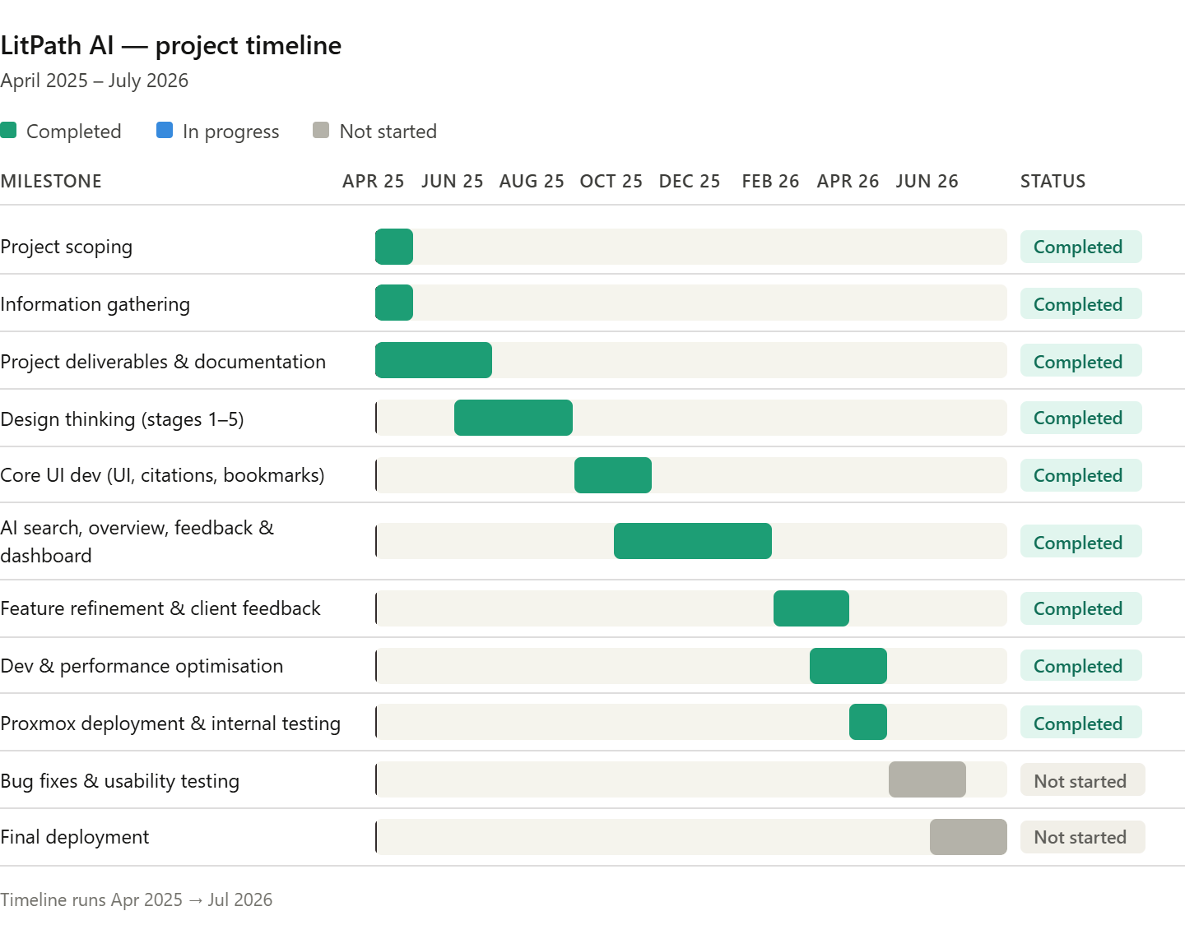
Milestone | Target Date | Status
Project Scoping | April 2025 | Completed
Information Gathering | April 2025 | Completed
Completion of Project Deliverables & Documentation | June 2025 | Completed
Design Thinking Process (Stages 1–5) | Aug 2025 | Completed
Core UI Development (System UI, Citation Generator, Bookmark) | Sep – Oct 2025 | Completed
AI Search Engine, Generate Overview, Feedback Mechanism & Admin Dashboard | Oct 2025 – Jan 2026 | Completed
Feature Refinement & Client Feedback Integration | Feb – Mar 2026 | Completed
Continued Development & Performance Optimization (incl. codebase restructuring) | Mar – Apr 2026 | Completed
Proxmox Server Deployment & Internal Testing | Apr 2026 | Completed
Bug Fixes & Usability Testing | May – Jun 2026 | Not Started
Final Deployment | Jun – Jul 2026 | Not Started

Early phases covering Project Scoping, Information Gathering, and initial Documentation were all completed on schedule by June 2025. The Design Thinking Process was finalized in August 2025, followed by Core UI Development from September to October 2025, which delivered the main interface, citation generator, and bookmark feature as planned.

Development of the more complex features including the AI Search Engine, Generate Overview, Feedback Mechanism, and Admin Dashboard was completed between October 2025 and January 2026. Feature Refinement and Client Feedback Integration followed from February to March 2026, incorporating evaluator and stakeholder input into the system.

As of May 2026, the team is actively working through Continued Development and Performance Optimization alongside Proxmox Server Deployment and Internal Testing. Bug Fixes, Usability Testing, and Final Deployment remain on schedule for May through July 2026.

Recommendations
This section should highlight any recommendations and lessons learned which would be of use on future projects. This is a valuable part of the project closeout phase and organizational project archives. In the project planning phase one of the first steps is to research organizational archives to identify useful information for planning and executing a project. These recommendations and lessons learned are one of the most important pieces or project success in any effective project management group. (could be upgrade of system)

Recommendation #1:
Establish a Deployment Checklist Before Final Release. As the project moves toward final deployment on the Proxmox server, a formal deployment checklist should be prepared covering environment variables, API key management, database migration scripts, CORS configuration, and Gemini AI API rate limit handling. This reduces the risk of production-specific issues surfacing after handover.

Recommendation #2:
Prioritize Usability Testing with Real Target Users. Since formal usability testing has not yet been conducted, the team should plan structured testing sessions with actual students and researchers before final deployment. This will surface usability issues that internal testing may have missed and provide evidence-based data to validate the system's target satisfaction score of at least 3.5 out of 5.

Recommendation #3:
Set Up Error Logging and Monitoring Using Sentry Before Final Deployment. As recommended by the client, the team could integrate Sentry for Django into the production environment prior to final deployment. Sentry provides real-time error tracking, detailed stack traces, and alerting capabilities that will allow the team to quickly identify and resolve issues after the system goes live on the Proxmox server. Configuring Sentry before deployment rather than after ensures that any errors encountered during the initial rollout are captured immediately and do not go unnoticed.

Sponsor Acceptance

Approved by the Project Sponsor:

Date: May 14, 2026
Khasian Eunice M. Romulo
Science Research Specialist II / Unit Head
(Digital Information and Processing Delivery Unit)

